**IOT Based Smart Parking System**

A Project report submitted in partial fulfillment of the requirements for the degree of B.E in

Computer Science Engineering

By

**M.JAYASHREE (513221104009)**

Under the supervision of the Professor & HOD department of Computer Science and Engineering

**SMART PARKING SYSTEM**

**PHASE 1: PROBLEM DEFENITION AND DESIGN THINKING**

* **Problem statement**
* **Design thinking approach**

**Problem statement:**

Once a car enters a parking garage followed by a parking space, a ping ultrasonic sensor will then be able to determine if a car is parked in the space or not.

In recent research in metropolitan cities the parking management problem can be viewed from various angles such as high vehicle density on roads.

The drivers usually waste time and effort in finding parking space and end up parking their vehicles finding a space on the street which further leads to space congestion. In worst case, people fail to find any parking space especially during peak hours and festive season.

This results in annoying issues for the drivers to park their vehicles.

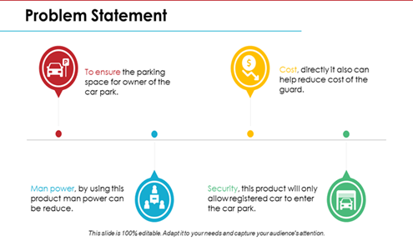

**Design thinking approach**

This model has the capacity of containing two cars. There are two sensors at the entrance to detect the presence of a car before going inside or outside of the parking lot. The other two sensors are plotted inside the parking lot to detect the car individually for each parking slot.

A DC Servo motor has been used at the entrance to open and close the gate according to the signals sent by the sensors through Arduino. The projection on the screen corresponds to the system model parking slots. This is a real time display regarding the status of the parking lot. As this is a web-based representation, anyone will be able to get the status of the parking lot by visiting the website on the URL through their cell phones, laptops, desktops and other internet supporting devices.

The model of the parking lot has two parking slots. Thus, we can park a maximum number of two cars through the system. We have used two IR sensors which when vehicle parked will show appropriate message to the user and when all the parking slots the dc motor would not open gate for the vehicle to be parked.

Displaying of appropriate message for any action which takes place in the parking zone is done effectively and efficiently.

This results in annoying issues for the drivers to park their vehicles as it is very difficult to find a parking slot.

The drivers usually waste time and effort in finding parking space and end up parking their vehicles finding a space on the street which further leads to space congestion. In worst case, people fail to find any parking space especially during peak hours and festive season**.**

